PRIDE OF SCOTTISH
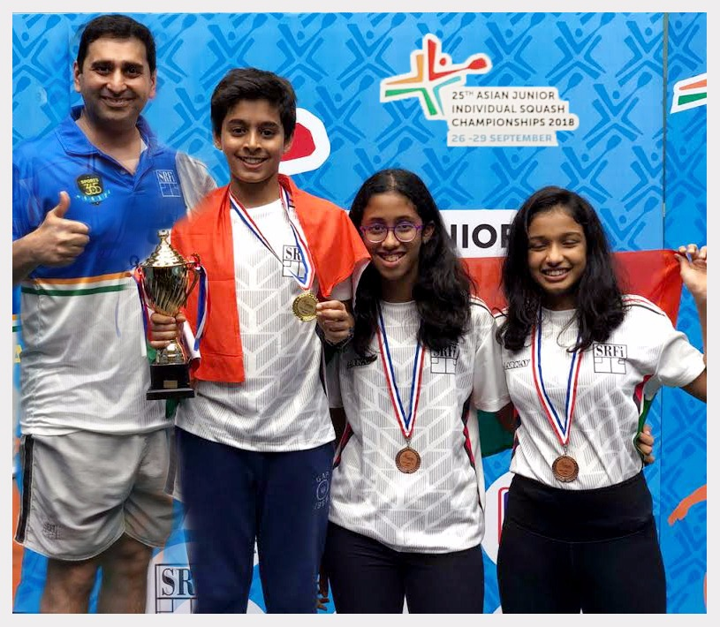
25TH ASIAN JUNIOR INDIVIDUAL SQUASH CHAMPIONSHIP 2018

PRIDE OF SCOTTISH
YUVRAJ WADHWANI [GOLD MEDALLIST]
KAAVYA BANSAL [BRONZE MEDALLIST]
TIANA PARASRAMPURIA [BRONZE MEDALLIST]
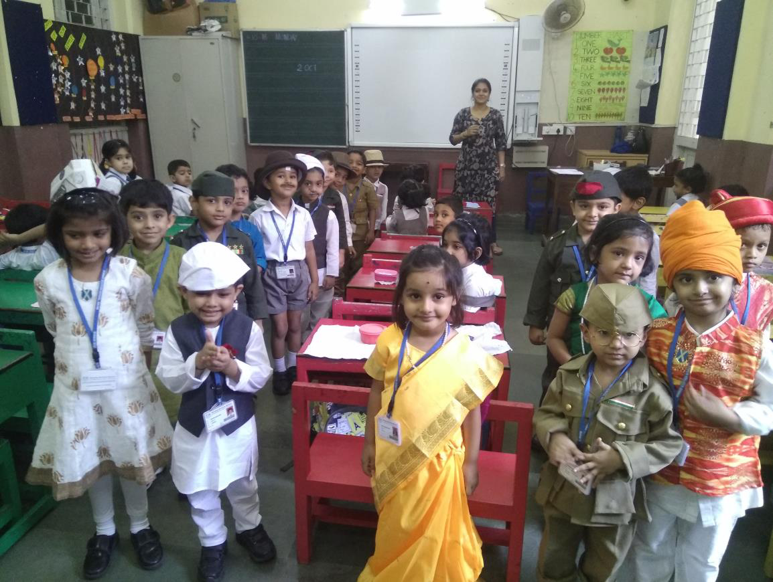
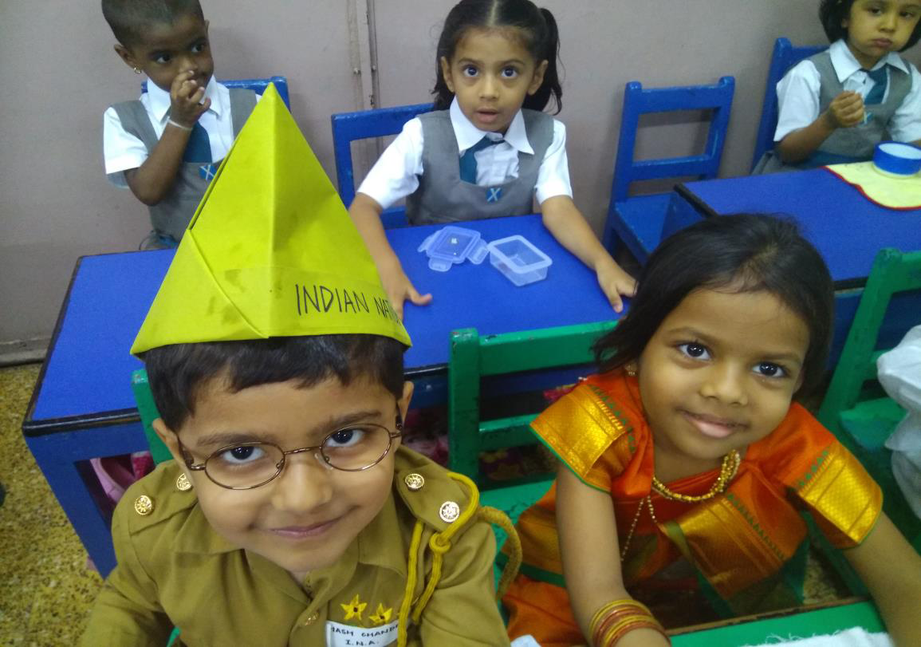
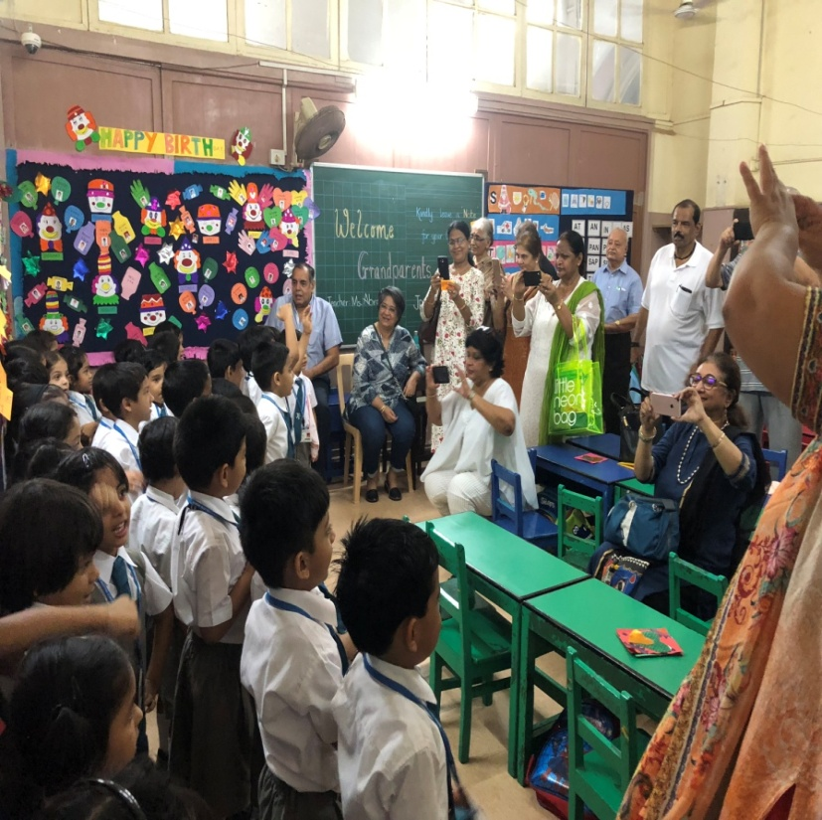
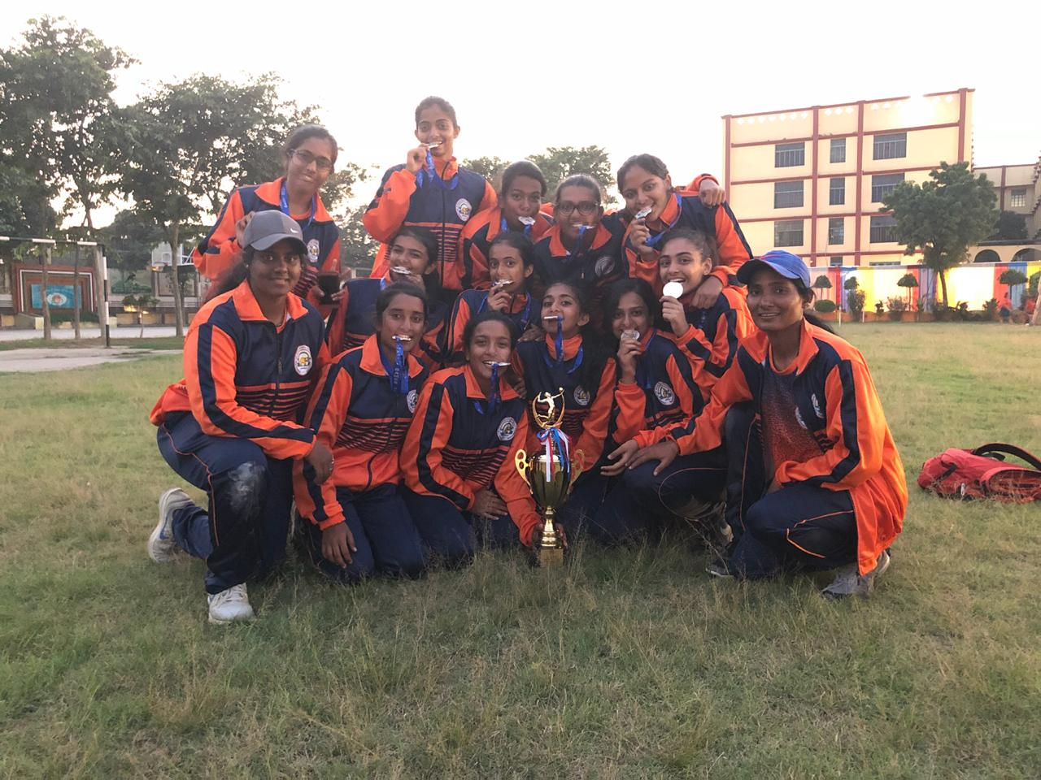
STANDING ALONGWITH THEM IS THEIR COACH MR. CYRUS PONCHA (AN ALUMUS OF BSS, MAHIM)

